ANALYSIS OF THIS SYSTEM DESCRIBED BY 

(1) This is a second order system. First, I use Matlab to identify its unit-step response and some parameters. Here is the code of Matlab.

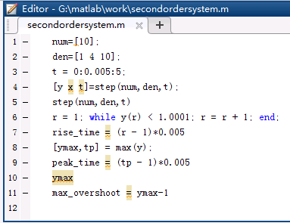

This is the plot of unit-step response.

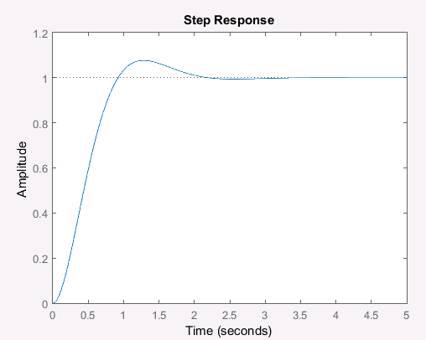

According to the result, I can identify some parameters:

:



:



:



:



Therefore, because, , , 

We can get, , , .

(2) According to transfer function , we can get:

, , .

Therefore, , , .

(3) Comparing these two sets of parameters, I find the results are almost same. A little difference results from calculation deviation.